International Razor Clam Digging Championships In Yukuhashi

Let’s play traditional spring event of Yukuhashi “Razor digging”! Easy to enjoy even a beginner. The razor digger master will teach you how to get it

Data April 15, 2018
Location Nagai-hama beach, Yukuhashi-shi, Fukuoka, Japan
Schedule 12:00 Reception open
13:30 until 15:00 Competition
15:30 Closing

Number of teams recruited : 50 teams (up to 4 people per team) required pre-registration
Participation fee : 1000 yen/1 team + number of participants × 500 yen (shell fee) (please pay at the reception on the day of the event.)
Participation: Please submit a registration form to Yukuhashi Tourist Association ( In the Yukuhashi Station) or send it via Email.
Preparation: Spades(1 per team), Salt, Bucket, and Boots
(If you do not have a spade, please ask Yukuhashi tourist Association )
Prize: Golden Spade(The top three teams have a wonderful bonus.)

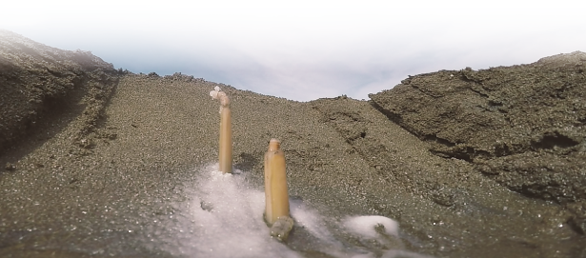
1St Prize Golden Spade

Registration form

Team Name

Members
Captain  (check) | Name | Address | Email or mobile phone number

Submission dead line: April 10, 2018
Submission: 2-1-1 Nishi Miyaichi Yukuhashi Fukuoka, Japan
Yukuhashi Tourist Association
Fax +81-930-25-0086
Email offie@yukuhashi-guide.jp

CONTACT
Yukuhashi Tourist Association
2-1-1 Nishimiyaichi Yukuhashi Fukuoka, Japan
Tel/Fax +81-930-25-0086
Email office@yukuhashi-guide.jp

